#RailDay2025 Social Media Recap

Hashtag Performance (obtained via BrandMentions.com)
- Total Mentions of #RailDay2025: 209
- Reach: 1.2 million
- Engagements (likes, shares, comments): 2,300

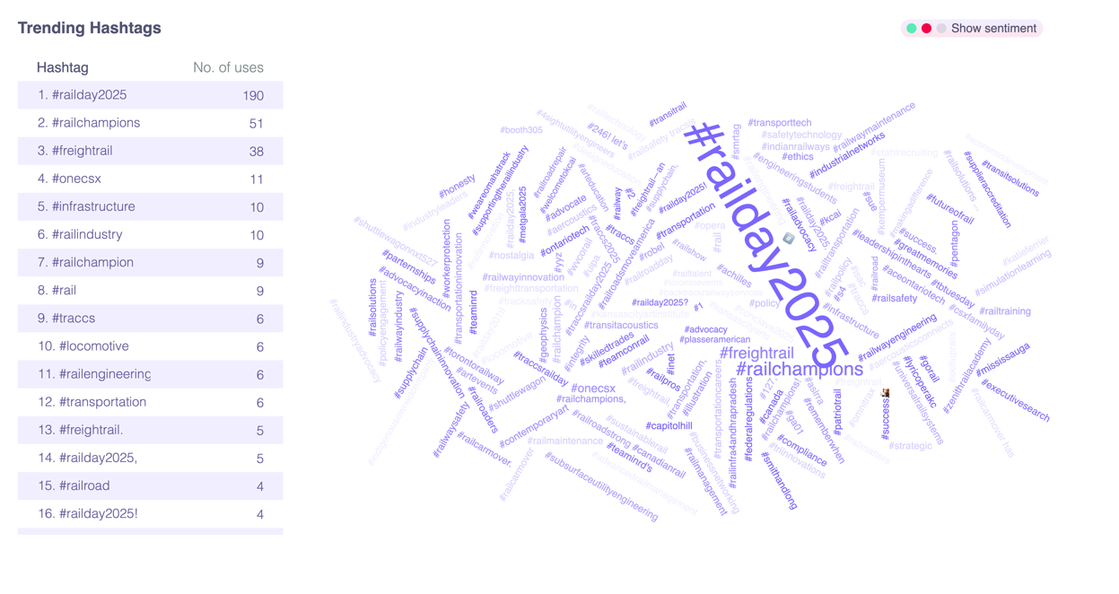

The hashtag sparked meaningful conversations around freight rail’s future. Not only did it trend among rail advocates, but also gained attention from Members of Congress and stakeholders.

📈 Top Trending Hashtags (besides #RailDay2025)
Hashtag | Uses
#RailChampions | 35
#FreightRail | 31
#RailPolicy | 19
#Infrastructure | 10
#RailSafety | 9
#CleanEnergy | 6
#Railroads | 4
#PermittingReform | 4

Platform & Conversation Performance

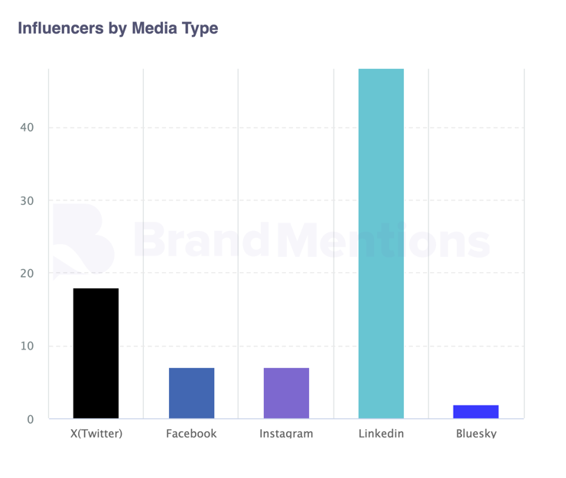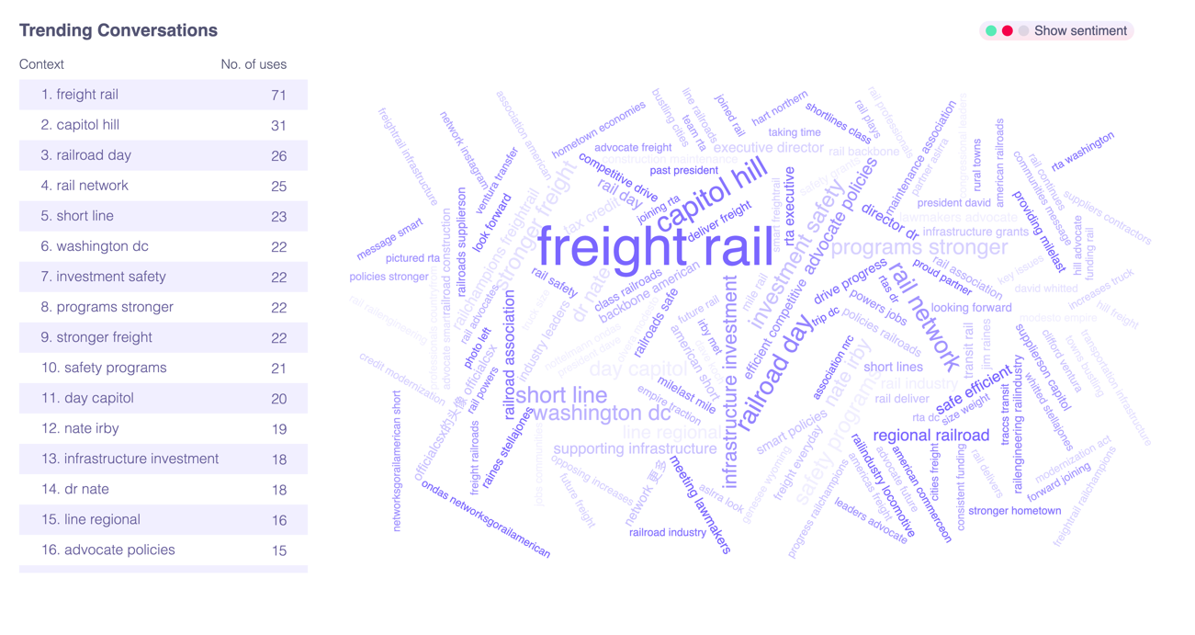

GoRail’s Best Performing Posts by Platform

X (Twitter)
🔗 View Post
Big thanks to @RepMikeKennedy for talking rail with us on #RailDay2025. From safety grants to faster permitting, Congress can make sure rail continues to support Utah’s 3rd district. @UTPortAuthority
📊 Impressions: 300+

Facebook
🔗 View Post
Passionate about freight rail’s role in powering our economy and protecting our planet? Become a #RailChampion this #RailDay2025!
🌐 RailChampions.org
📊 Views: 296

Instagram
🔗 View Post
From rural towns to bustling cities, freight rail is the backbone of American commerce.
On #RailDay2025, we're meeting with lawmakers to advocate for policies that keep our railroads safe, efficient, and competitive. Together, we drive progress. 🚆
📊 Views: 121

Member of Congress Engagement
These Congressional offices posted or boosted our message:
- Rep. Mike Kennedy, M.D. – Retweet & Like
- Rep. Buddy Carter – Facebook Post
- Rep. Hank Johnson – Tweet
- Rep. Robin Kelly – Tweet

Takeaways
- Multi-platform strategy worked, but LinkedIn was missing on the day of. Let's fix that next year.
- Photos of face-to-face interactions performed best (Nate & Ben post was a top performer). More field-generated content = more engagement.
- #RailDay2025 had strong brand association with #RailChampions — let’s build on that pairing moving forward.

Recommendations for 2026
- Post on LinkedIn day-of
- Encourage MOC & staff to post more to create more of a conversation with them
- Empower GTs and Field Staff to text photos in real time to post day-of.
- More real moments = higher engagement. Action shots > posed group pics.

